Sydney St Patricks Day Parade 2022 Application Form
Sunday 20th March 2022

www.sydneystpatricksday.com

The Sydney St. Patrick’s Day Organisation is a not for profit organisation managed by a group of professional volunteers. The St Patrick’s Day celebrations are made possible thanks to the efforts of the volunteer committee and the team of individuals who give up their time before, during and after the event. This year’s committee brings together experience, creativity and dedication to build a world-class event known locally and internationally.

The Organisation founded a committee to take responsibility to revitalise the St. Patrick’s Day celebrations in the city and to create a family orientated, multicultural event with an emphasis on community involvement.

OUR MISSION

To deliver to the greater community of Sydney a world-class St Patrick’s Day celebration. A professionally organized event that reflects the true nature of a progressive, diverse and modern Irish community.

In 2022 Sydney St Patrick’s Day Festival is celebrating our sense of culture and heritage by lining the streets of The Rocks with splashes of green and then continue the celebrations at First Fleet Park, MCA Lawn, Bligh & Barney Reserve and Upper Foreshore area (by Circular Quay) for our family fun day.

Sydney St Patrick’s Day relies on the support from sponsors, fundraising initiatives and volunteers. If you would like to get involved, contact us at fundraising@sydneystpatricksday.com.au

We have created this parade kit to ensure you have all the necessary dates and information to take part in this years’ parade.

IMPORTANT DATES

Friday 25/02/2022 Parade Applications close Sunday 13/03/2022 Parade Briefing Day
Sunday 20/03/2022 Day of the parade (followed by the festival)

2022 THEME

The theme for the 2020 Festival Parade is “Where the Emerald Isle meets Emerald City” as approved by the Festival Committee. Wear a nice Emerald Green!

CONDITIONS OF ENTRY

  - Motor vehicles are prohibited - this is a walking parade only (push bikes are allowed)

  - Fire, open flames, pyrotechnics, flares, fire batons, fire breathing, sparklers, sparks, welding, hazardous, flammable goods are not prohibited.

  - All participants are to display a banner during the parade and are to indicate prominently what organisation/group they support.

  - Any animals are to be adequately supervised and on leads, will require their owners to collect and up their waste. Permitting your animal to excrete on a street or public place and failing to remove or adequately dispose of such constitutes an offence under the City’s Local Laws.

  - No items may be thrown into the crowd at any time.

  - Participants who wish to provide giveaways to the public along the parade route will need to express written permission from the event organisers prior to the day.

  - The order of participation in the parade is at the sole discretion of the event organisers.

  - Sydney St Patricks Day Organisation accepts no responsibility for any loss or claim arising out of participation in the parade, but all care has been taken to ensure a safe and secure parade. Entries are voluntary and at the participant's risk.

SAFETY

Personal interaction with the crowd is encouraged - this makes the crowd feel welcome and increases the impact of the PARADE. However, participants are not permitted to throw projectiles (lollies etc) into the crowd.

Emergency access lanes within the assembly area and along the PARADE route are designated emergency access lanes. These will be communicated to you at the Entrants Briefing and at Registration on the day of the PARADE.

Emergency access lanes are for the use of all emergency services vehicles before and during the PARADE. These lanes must be kept clear at all times. Any people and props within these lanes will be removed.

The PARADE route is not exempt therefore authorities are within their right and will enforce the law to act on any breaches at their discretion.

FREQUENTLY ASKED QUESTIONS

When is the PARADE?
The PARADE on Sunday 20th March will start at 10.30am sharp.

Where does the PARADE take place?

The PARADE begins at corner George Street & Hickson Road, The Rocks and ends on entry to First Fleet Park (George Street before Alfred Street).
Gathering for registration from 8am-9am at Dawes Point Park

What is the theme of this year’s PARADE?

The theme of our 2020 parade is “Where the Emerald Isle meets Emerald City”

Are there prizes for the best entry?

Yes, there are! The prize categories will be determined closer to the date, but there will be a prize-giving ceremony at First Fleet Park after the parade...including a $500 cash prize! So get creative.

What makes a fantastic PARADE entry?

There are many ways to increase the visual impact of your entry and contribute to the colour and spectacle of the PARADE. Consider using lightweight flags, carriables, costumes, choreography, colour and uniqueness to your entry, and remember that the Internet is a great resource for brainstorming your entry.

How much does it cost to enter the PARADE?

The entry to the parade is free.

How many people do you need to make up a PARADE Entry?

The more the merrier, up to a maximum of 30 people per entry. Due to the area of the parade, it is a walking parade only. Numbers over 30 would need further discussion.

How long is the parade route?

The route is approx. 500mtrs. It will start at Hickson Road and will finish at the corner of George & Alfred Street in Circular Quay where it will turn in under the Cahill Expressway and end in First Fleet Park. Route will be walked on the day of the briefing – Sunday March 13th.

How are children involved in the parade?

The parade is open to Children and adults. The Children along with their parent or guardians will be grouped together within the parade. We must have ages and names of children who will march in the parade.

How fast does the PARADE move?

The PARADE is designed to continually move forward at walking pace. If your entry is unable to maintain this rate, gaps begin to appear, and audiences walk away with a less cohesive picture of the PARADE as a whole. Make sure your entry moves forward at all times,
particularly if you are using choreography!

Where will I be positioned in the parade?

Parade placement is at the sole discretion of SSPD (Sydney St Patrick’s Day) organisation. The SSPD Parade team work hard to curate a Parade with exciting messaging that tells a story to our audience. Parade order is an important part of this decision-making process and while consideration will be given to factors such as participants ages and abilities, the Parade order is at the discretion of the SSPD Parade team.
On Parade day, all Entrants must line up in the section to which they have been assigned and must do so at the designated time and location. Each group must stay in its section for the duration of the Parade. SSPD Start Marshalling Volunteers will be at your assigned block to help ensure proper line-up.

What happens after the PARADE?

The PARADE concludes at First Fleet Park where we then continue the celebrations with a family fun day and festival for all ages.

ON PARADE DAY....

  - Bring your PARADE Start documentation (supplied at the PARADE Entrant’s Briefing)
  - Allow sufficient journey time in case of traffic and congestion from other arriving entries
  - Follow the correct route to your designated entry point, registration and assembly areas (Access to the assembly area cannot be gained via the PARADE route at any time)
  - Ensure your entry meets the compliance requirements explained in this guide.
  - Bring food and refreshments – it’s a long day and night!
  - Bring an emergency repair kit
  - Bring a first aid kit – Band-Aids, sun cream, etc.

CONDITIONS OF ENTRY

  - Placement in the PARADE will be at the discretion of the event committee and PARADE event manager

  - Priority of placement will be at the discretion of the event committee and PARADE event manager

  - Sydney St Patrick’s Day Organisation will comply with all State and Local Government regulations in staging the PARADE and will carry public liability insurance for the event.

  - Sydney St Patrick’s Day Organisation does not accept responsibility for damages, financial or otherwise, that may occur as a result of bad weather.

2022 PARADE APPLICATION FORM

Completed applications must be returned via email to
parade@sydneystpatricksday.com.au by Friday, 25th February 2022.

If you have any questions regarding your application, please email Lorraine on the email above.

This year’s Parade will start on Sunday 20th March at 10.30am Sharp. Marshalling will commence at 8-9am at Dawes Point Park. See below map. There are a few Wilson parking stations in the area. For assembly at Dawes Point Park we recommend using the one at Barangaroo.

Please complete your details below: Name of Group / Organisation:

Contact Name:

Postal Address:

Mobile Number:

Email Address:

Please note primary communication will be by email.

Entry DESCRIPTION
A brief description of your design, participants age group and number of participants and how it fits with the theme:

List any requirements for your group e.g. Lights / PA System
N/A if you are entering an individual child walking

What is the name of your entry?
N/A if you are entering an individual child walking

Type of Entry
Float Type | Tick relevant
Individual
Unfunded Community Group
Funded Community / Political Group
Corporate or Government

If you are entering a child/children into the children’s section of the parade please complete the below;

Child’s Name | Child’s Age | Name and contact details of adult/guardian responsible for child/children

Please submit your completed application to parade@sydneystpatricksday.com.au by Friday, 25th February 2022.

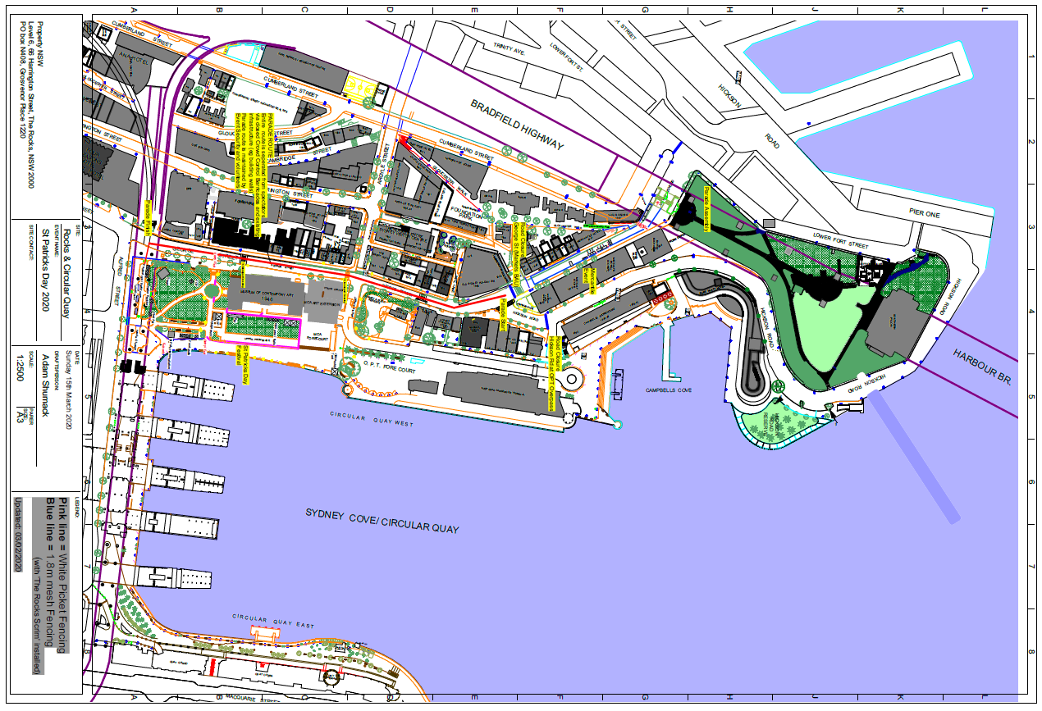
PARADE END AT CAHILL EXPRESSWAY/ALFRED STREET, 11.45am
PARADE START AT GEORGE STREET/HICKSON ROAD, 10.30am
PARADE ASSEMBLY AT DAWES POINT PARK
SSPD FESTIVAL AT FIRST FLEET PARK

